Procedure for Remote Support

1. Please stop sending requests for programming help via email, we need a more efficient way of providing support.
2. Requests for other support and information are fine by email.
3. Before you contact your tutor check the discussion board now available on BB to see if your question has already been answered.

Discussion board available here…

<https://vle.dmu.ac.uk/webapps/blackboard/content/listContentEditable.jsp?content_id=_4591450_1&course_id=_550815_1&mode=reset>

1. If there is no solution there, then post your question to the discussion board and patiently await a reply.
2. If it is not possible to solve the problem via the discussion board then contact your tutor directly to arrange a virtual meeting.

Matthew– use the booking system on the web site

Dawn– email

Salimah– email

Peter– email

1. In advance of any meeting make sure you proved the following details by email
   1. Azure Credentials, server, database name, username and password
   2. The name of your section (staff/customer etc.)
   3. Make sure that your database owner has added your tutor to the firewall rules for your server

Dawn

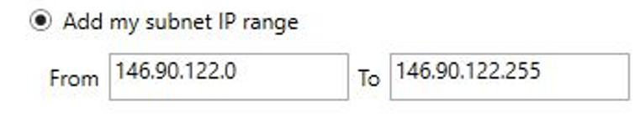

Salimah

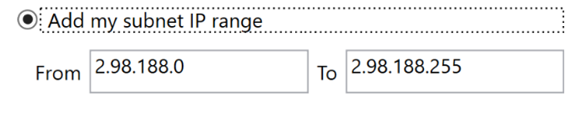

Matthew

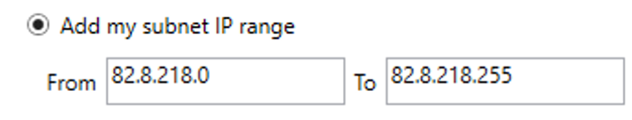

Peter

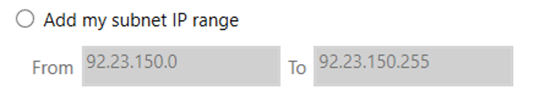

* 1. Zip up your work make sure the zip file is named with your full name and P number, e.g.



* 1. Upload your work to the OneDrive folder for your tutor

Dawn

<https://demontfortuniversity-my.sharepoint.com/:f:/g/personal/djohns02_dmu_ac_uk/EvLmyyjaw01PpBGLCgnhiyEBUxQB9oWxpq3n4daw1x-CRg?e=zEtiyM>

Matthew

<https://demontfortuniversity-my.sharepoint.com/:f:/g/personal/mdean00_dmu_ac_uk/EkOWJXOQb-ZDmmOAjBAz-eEBDEjZaSxEHJExotFs4jK4HQ?e=MgJ16Q>

Peter

<https://demontfortuniversity-my.sharepoint.com/:f:/g/personal/plmb_dmu_ac_uk/EmounnPetM5DnB-imGqh2AUBMdZDT2dEe6Nu2ohWExdR0g?e=39K5Wf>

Salimah

<https://demontfortuniversity-my.sharepoint.com/:f:/g/personal/smoham04_dmu_ac_uk/EkfAuzQomoNKjcCsAMMxC4IBDSRcl2NdX-FvlBiKoIVgUA?e=tePyuZ>

* 1. Respect that you may see work belonging to other students in the shared folder – if it doesn’t have your name on it please leave it alone
  2. Attend the virtual meeting, if you cannot attend please let your tutor know, please try not to be late as other students need help too!
  3. When you collect your work after the meeting please delete it off the OneDrive link, again please take care not to interfere with work belonging to others